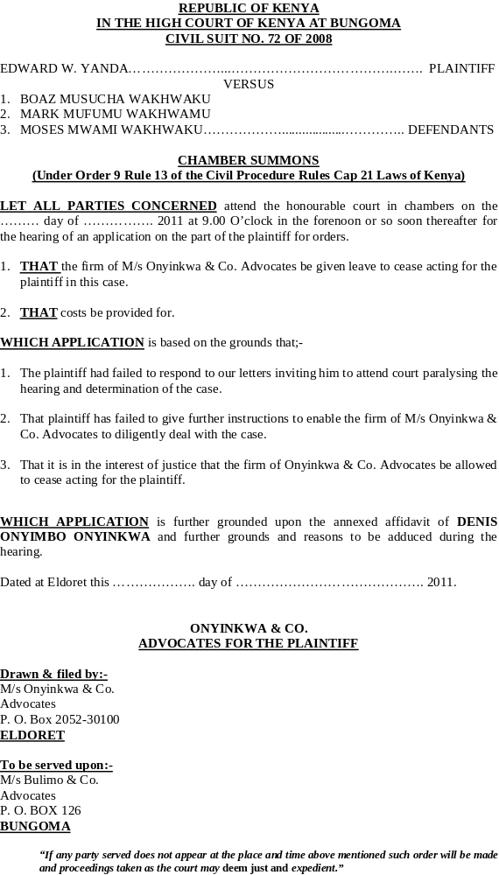

REPUBLIC OF KENYA
IN THE HIGH COURT OF KENYA AT BUNGOMA
CIVIL SUIT NO. 72 OF 2008

EDWARD W. YANDA …… ………………………………. PLAINTIFF/APPLICANT

VERSUS

- BOAZ MUSUCHA WAKHWAKU
- MARK MAFUMU WAKHWAKU
- MOSES MWAMI WAKHWAKU………………DEFENDANTS/RESPONDENTS

SUPPORTING AFFIDAVIT

I IBRAHIM JOSEPH ONYINKWA of P. O. Box 2052-30100 Eldoret do hereby solemnly make oath and state as follows;-

- THAT I am an Advocate of the High Court of Kenya practicing as such with the firm of M/s Onyinkwa & Co. Advocates and I am seized with the conduct of this matter on behalf of the plaintiff/ applicant hence competent to make and swear this affidavit.

- THAT this matter was initially instituted in Kakamega court vide Kakamega HCCC No. 82 of 2006.

- THAT upon the application by the defendants the same was transferred to Bungoma court and registered afresh vide Bungoma HCCC No. 72 of 2008.

- THAT on or about 28/5/2010 the court on its own motion dismissed the suit although none of the parties attended court on that day.

- THAT my law firm was never served with the Notice for Dismissal of the suit by the court. I only found an unsigned copy of the call over Notice in the court file but no return of service on the court file (annexed is a copy marked ‘IJO 1’).

- THAT upon my personal perusal of the court file I have discovered that although the order for dismissal was written by the Deputy Registrar, the same was not signed by the Judge to make the same valid and legal (annexed is the hand written endorsement made on 28/5/2011 marked ‘IJO 2’) .

- THAT since the endorsement was not signed by the judge the court order although made by the Deputy Registrar was not signed by the Judge and the same is therefore invalid.

- THAT it is on the strength of this that I pray to the court to set aside the same and reinstate the case for hearing on its own merits.

- THAT unless the order sought are granted the defendants are likely to proceed with execution without even drawing any decree as they appear to have merely filed a bill of costs.

- THAT should execution be done against the defendant on an invalid dismissal my client will suffer irreparable loss and damage.

- THAT all deponed to above is true to the best of my own knowledge, information and belief save where the sources of information have been disclosed.

Sworn at Eldoret by the said }

IBRAHIM JOSEPH ONYINKWA }……………………………………..
DEPONENT
this ……. day of ……………. 2011 }

BEFORE ME }

}

COMMISSIONER FOR OATHS }

Drawn & filed by:-
M/s Onyinkwa & Co
Advocates,
P. O. Box 2052-30100
ELDORET

